When signing up for Web Grants:
An external user will need to have an ND Login to access WebGrants. Notes with links to ND Login assistance are on the Announcements section of the login page. This is page one of this document.

- User will set up a new ND Login account IF they do not already have one. (Many have ND Login accounts for Game & Fish, Parks, or other State applications.)
- User will need to verify both email and phone number on the ND Login account when it's created.
- User will log into WebGrants and register their account. The user will receive the email below. FIND Admins will need to approve the user within WebGrants.
Important: Make sure that you pick the Funding for Infrastructure in ND - FIND Program funding opportunity!
The sign in screen will look like this.
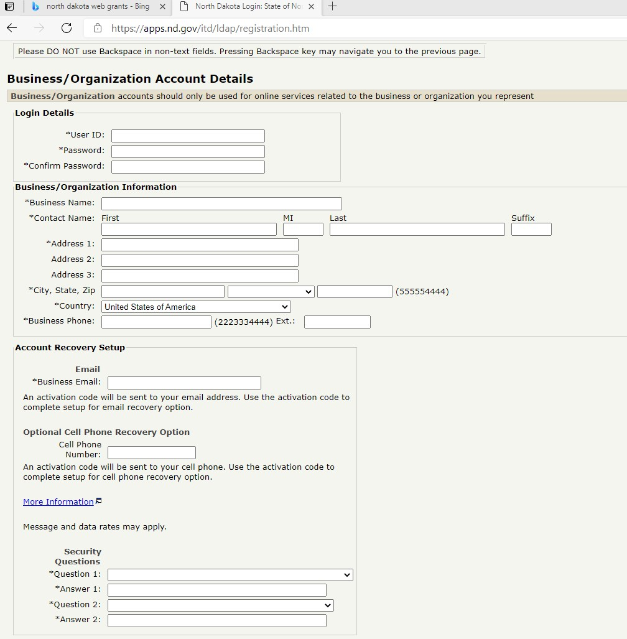

Please fill out this information when signing in. Once finished, you will be receiving an email that looks like this.
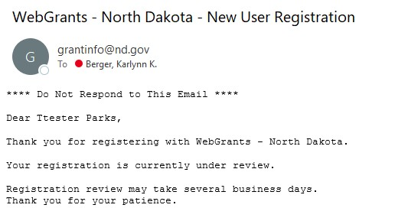
It may take a couple of days for the FIND admin to approve access. Once the FIND administrator has approved the user, they will receive this following e-mail.
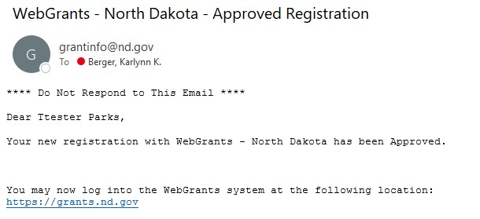
- Once FIND Admins have approved the user, they will be able to log into WebGrants with their ND Login information.

Important Additional Information: External User Sign-in for Web Grants
You MUST follow the steps below PRIOR to logging into WebGrants!
WebGrants will not allow access until AFTER you have:
- Log into the NDLogin app to confirm account exists or to unlock your existing account: NDLogin Link
- If a successful login, set the recovery phone number and request a verification text to activate the account (The security phone number is not required when setting up an ND Login account, but if not populated you can’t log in to WebGrants).
- Once completed, you should enter your NDLogin login credentials to log into WebGrants
If you already have a North Dakota login that works with other ND apps, you do not need to create a new account!
If you do not have an existing NDLogin you MUST set one up prior to logging in to request access to WebGrants.
There is a video detailing how to log into Web Grants on the sign-in page.
WebGrants uses a NDLogin authenticator, and your account will be locked if you try to request WebGrants access before you have an approved NDLogin.
There is a North Dakota register link on the sign-in page.
*This information is located on the announcement page to WebGrants.

